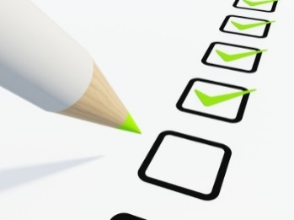
My Self-Monitoring Checklist
Name: _________________________________
Date: __________________________________

Today I am working on (do this part with your teacher):
Completing my classwork Having respectful behavior Making good choices
Being kind to others Keeping my hands to myself Listening to my teachers

Morning Class
Did I….?
Complete my classwork Have respectful behavior Make good choices
Be kind to others Keep my hands to myself Listen to my teachers

Ask for help when I needed Help others in need Do a good job
Special (1)
Did I….?
Complete my classwork Have respectful behavior Make good choices
Be kind to others Keep my hands to myself Listen to my teachers

Ask for help when I needed Help others in need Do a good job
Special (2)
Did I….?
Complete my classwork Have respectful behavior Make good choices
Be kind to others Keep my hands to myself Listen to my teachers

Ask for help when I needed Help others in need Do a good job
Afternoon Class
Did I….?
Complete my classwork Have respectful behavior Make good choices
Be kind to others Keep my hands to myself Listen to my teachers

Ask for help when I needed Help others in need Do a good job
Overall today I: Did a great job! Did okay, but want to do better. Tried, but did not do my best. (Circle one)

